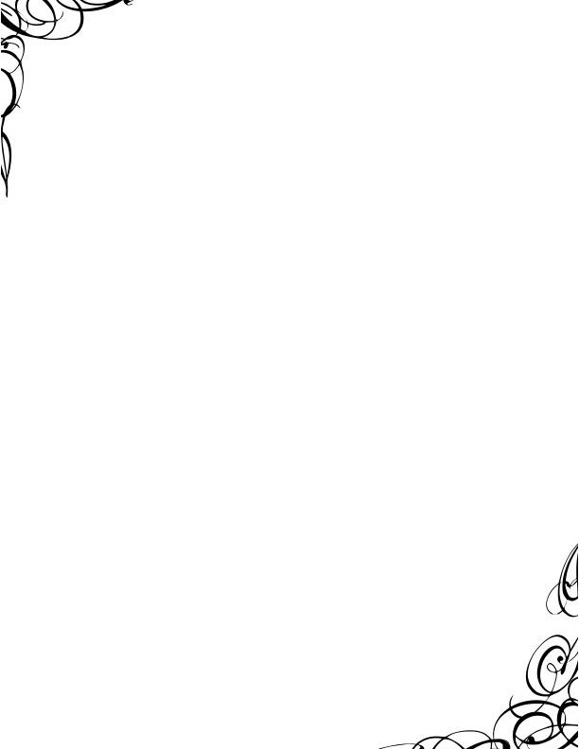**Poetry Forms**

**Acrostic** - Poetry in which certain letters, usually the first in each line, form a word or message when read in a sequence.

**Teacher**

Trainer of fresh young minds,  
Educator of tomorrow's leaders,  
A friendly face every morning,  
Challenges students to reach higher,  
Helps every child learn new skills,  
Eager to see a class pass the test,  
Ready to answer every one's questions

**Ballad** - A poem that tells a story similar to a folktale or legend which often has a repeated refrain.

**Excerpt of “The Mermaid” by Unknown author**Oh, the ocean waves may roll,   
And the stormy winds may blow,   
While we poor sailors go skipping aloft   
And the land lubbers lay down below, below, below   
And the land lubbers lay down below…

**Cinquain** - Poetry with five lines. There are several different kinds but one pattern is as follows: Line1: A noun; Line2: Two adjectives; Line 3: Three -ing words; Line 4: A phrase; Line 5: Another word for the noun

MC900048792[1]**Spaghetti**Messy, spicy  
Slurping, sliding, falling  
Between my plate and mouth  
Delicious

**Couplet** - A couplet has rhyming stanzas made up of two lines.

**My Cat**

By Molly (at age 5)

I like to play with my cat

He likes to get in a hat.

**Diamante** – poetry with seven lines, shaped like a diamond. It is similar to the Cinquain.

**MC900325540[1]Lion**  
Majestic, proud  
Roaring, snarling, prowling  
Mane, muscle . . . Fleece, fluff  
Bleating, leaping, grazing  
Meek, gentle  
Lamb



**Epic** - An extensive, serious poem that tells a story about a heroic figure.

Example: the Iliad and the Odyssey by Homer

**Free verse** - A poem written that is unrhymed and without any rhythmic pattern.

MC900437451[1]**Haiku** - A Japanese poem composed of three unrhymed lines of five, seven, and five syllables. It is usually about nature, particularly seasons.

The red blossom bends

and drips its dew to the ground.

Like a tear it falls

**Limerick** – A 5-lined rhyming poem that is often humorous, mean-spirited, or vulgar.

There once was a fellow named Tim

whose dad never taught him to swim.

He fell off a dock

and sank like a rock.

And that was the end of him.

**Ode** - A lengthy lyric poem typically of a serious or meditative nature and having an elevated style and formal stanza structure.

**Except: 624. Ode to a Nightingale by John Keats**

MY heart aches, and a drowsy numbness pains

My sense, as though of hemlock I had drunk,

Or emptied some dull opiate to the drains

One minute past, and Lethe-wards had sunk:

'Tis not through envy of thy happy lot, 5

But being too happy in thine happiness,

That thou, light-wingèd Dryad of the trees,

In some melodious plot

Of beechen green, and shadows numberless,

Singest of summer in full-throated ease. 10 …

**Quatrain** - A stanza or poem consisting of four lines. Lines 2 and 4 must rhyme while having a similar number of syllables.

from Thomas Gray's "Elegy Written in a Country Churchyard")

The Curfew tolls the knell of parting day,

The lowing herd wind slowly o'er the lea,

The plowman homeward plods his weary way,

And leaves the world to darkness and to me.

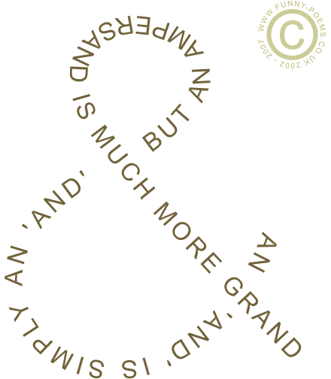**Sonnet** (Shakespearean) - A 14-line sonnet consisting of three quatrains of abab cdcd efef followed by a couplet, gg. Generally uses iambic pentameter.

**Shape** - Poetry written in the shape or form of an object.